Project Design Phase-II
Technology Stack (Architecture & Stack)

Date | 30 September 2026
Team ID | SWTID-2026-1691
Project Name | AI BlogNest API
Maximum Marks | 4 Marks

Technical Architecture:
The Deliverable shall include the architectural diagram as below and the information as per the table1 & table 2
Technical Architecture – AI BlogNest API
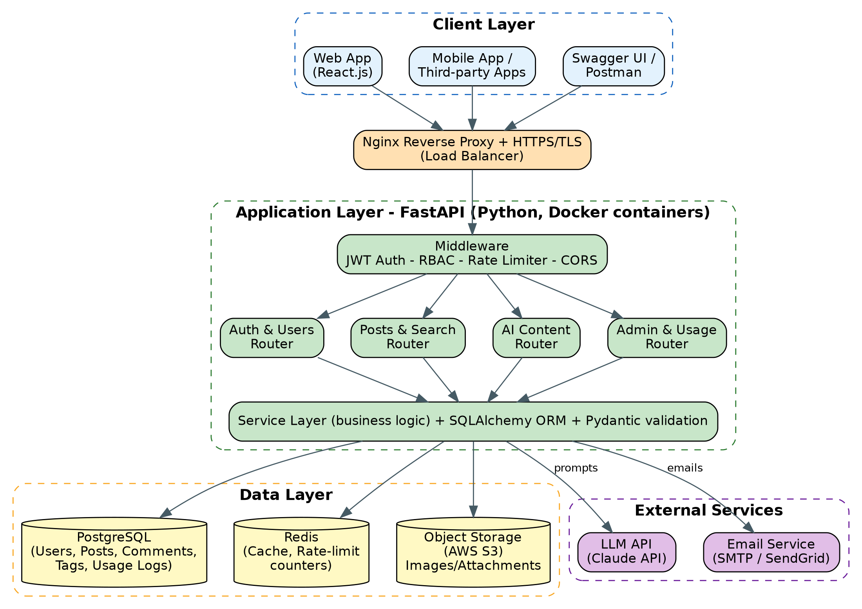
Table-1 : Components & Technologies:
S.No | Component | Description | Technology
- 1 | User Interface | Consumers use web / mobile clients or API tools (Swagger UI, Postman) to call the REST API. | React.js (sample client), Swagger UI / OpenAPI
- 2 | Application Logic-1 | Authentication and user management: registration, email confirmation, login, JWT, role-based access. | Python, FastAPI, PyJWT, bcrypt
- 3 | Application Logic-2 | Blog post management, publishing, search, comments and likes. | Python, FastAPI, SQLAlchemy, Pydantic
- 4 | Application Logic-3 | AI Content Service: builds prompts and processes responses for drafts, rewriting, titles, SEO description and tags. | Python, LLM SDK (Claude API)
- 5 | Database | Relational data: users, posts, comments, tags, API keys and usage logs. | PostgreSQL
- 6 | Cloud Database | Managed database service in the cloud with automated backups. | AWS RDS for PostgreSQL
- 7 | File Storage | Post images and attachments. | AWS S3 (local filesystem in development)
- 8 | External API-1 | Large language model API for text generation. | Claude API (Anthropic)
- 9 | External API-2 | Transactional emails for confirmation and password reset. | SMTP / SendGrid
- 10 | Machine Learning Model | Large language model used through an API for content generation (not trained in-house). | Claude model via API
- 11 | Cache & Rate Limiting | Caches frequently read posts and stores per-user rate-limit counters. | Redis
- 12 | Infrastructure (Server / Cloud) | Application deployment on local system / cloud.  Local Server Configuration: Docker Compose (FastAPI, PostgreSQL, Redis).  Cloud Server Configuration: containerised services on AWS (EC2 / ECS) behind Nginx or a load balancer. | Docker, Nginx, AWS EC2 / ECS, GitHub Actions (CI/CD)

Table-2: Application Characteristics:
S.No | Characteristics | Description | Technology
- 1 | Open-Source Frameworks | Open-source frameworks and libraries used in the backend. | FastAPI, SQLAlchemy, Pydantic, Alembic, Pytest
- 2 | Security Implementations | Authentication, access control, encrypted transport, input validation and rate limiting. | JWT, bcrypt, RBAC, HTTPS / TLS, OWASP Top 10 practices
- 3 | Scalable Architecture | Layered design (router, service, data access) with stateless containers that scale horizontally; can be split into microservices. | Docker, Nginx load balancer, PostgreSQL
- 4 | Availability | Multiple app instances behind a load balancer, health checks, automatic restarts and database backups. | Nginx / AWS ALB, Docker restart policies, RDS backups
- 5 | Performance | Async endpoints, Redis caching for hot reads, database indexes, pagination and background tasks for heavy jobs. | asyncio, Redis, PostgreSQL indexes

References:
https://c4model.com/
https://developer.ibm.com/patterns/online-order-processing-system-during-pandemic/
https://www.ibm.com/cloud/architecture
https://aws.amazon.com/architecture
https://medium.com/the-internal-startup/how-to-draw-useful-technical-architecture-diagrams-2d20c9fda90d

